**Money Matters**

**Update on the County Council's Reserves Position as at 30th September 2016**

|  |  |
| --- | --- |
| **Contents** | **Page** |
| **1. Introduction** | **3** |
| **2. Summary** | **3** |
| **3. Reserves** | **5** |
| **4. Impact of 2016/17 Outturn Forecast** | **7** |
| **5. Transfers between Reserves** | **8** |
| **Annex A – Strategic Investment Reserve** | **9** |
| **Annex B – Downsizing and Risk Management Reserve** | **10** |
| **Annex C – Transitional Reserve & Transition of Services Reserve** | **11** |
| **Annex D – Service Reserves** | **12** |

Money Matters – Update on the County Council's Reserves Position for 2016/17

**1. Executive Summary**

**1.1 Introduction**

As at 1st April 2016 the County Council had total reserves of £400.669m. Of this, £86.022m was held for schools and its use is restricted.

This report sets out the reserves position in line with the current budget monitoring report.

**1.2 Summary**

As part of the process of redesigning its services the County Council has previously explicitly recognised that it will need to significantly utilise its reserves over the next 2 financial years.

At Full Council in February 2016 the revenue budget included an approved commitment from the Transitional Reserve of £46.518m in 2017/18 to support the reported financial gap at that time. However, following a review of the Medium Term Financial Strategy (MTFS) for Cabinet in September 2016 it was identified that a revised value of £47.978m was required in 2017/18 which resulted in an additional £1.460m added into the MTFS.

A further quarterly review of the MTFS has taken place (Appendix B) it is now identified that £60.350m is required in 2017/18 (an additional £12.372m compared to September 2016 figures reported to Cabinet). The additional requirement **has been included within the reserves forecast detailed within this report.**

The budget monitoring position for the financial year 2016/17 (Appendix A) is reporting a forecast underspend of £13.271m. **Please note that this is not currently included within the forecast reserves position in this report.**

In summary, by 31st March 2018 it is expected that there will only be the £36.000m County Fund and a residual £79.767m of service reserves which includes £8.354m school PFI expenditure and £5.084m which is not LCC money, meaning in effect the available balance of £66.329m. All other reserves will have been spent. If the additional contribution from revenue is available of £13.271m (budget monitoring forecast underspend), this will result in a balance of service reserves being available as at 31st March 2018 of £79.600m.

When reviewing the County Council's reserves in conjunction with the Medium Term Financial Strategy (Appendix C) the funding requirement to bridge the financial gap in 2018/19 would total £86.846m. Although there are reserves available at 31st March 2017 of £79.600m (if the currently forecast underspend is achieved) there are commitments in 2018/19 of £10.473m (excluding non LCC commitments) therefore the available balance to support the 2018/19 budget is £69.127m resulting in there not being sufficient funds within reserves to support the 2018/19 budget.

In summary, this report indicates that there is potentially sufficient funds within reserves to deliver a balanced budget in 2017/18. However this is dependent upon a number of key factors:

* The forecast in year overspend is minimised.
* All values within reserves that are currently reported to be available funds are transferred into the transitional reserves with no further commitments emerging in these areas now that the transfer has taken place.
* There is limited slippage on the agreed savings programme for 2017/18 and 2018/19. As any slippage will result in a requirement for funding from reserves.

**3. Reserves**

The table below illustrates the summary forecast position in respect of the Council's reserves:

|  |  |  |  |  |  |  |  |  |
| --- | --- | --- | --- | --- | --- | --- | --- | --- |
| **Reserve Name** | **Opening Balance as at 1 April 2016** | **2016-17 Forecast Spend** | **2016-17 Transfers to / from other reserves** | **2016-17 Forecast Closing Balance** | **2017-18 Forecast Spend** | **2018-19 Forecast Spend** | **2019-20 Forecast Spend** | **Total as at 31 March 2020** |
|  | **£m** | **£m** | **£m** | **£m** | **£m** | **£m** | **£m** | **£m** |
| County Fund (3.1) | -36.000 | 0.000 | 0.000 | -36.000 | 0.000 | 0.000 | 0.000 | -36.000 |
| Strategic Investment Reserve (3.2) | -10.971 | 2.351 | 5.194 | -3.426 | 1.543 | 0.883 | 0.060 | -0.940 |
| Downsizing Reserve (3.3.1) | -64.841 | 14.171 | 28.462 | -22.208 | 13.148 | 9.060 | 0.000 | 0.000 |
| Risk Management Reserve (3.3.2) | -15.784 | 3.939 | 4.872 | -6.973 | 6.973 | 0.000 | 0.000 | 0.000 |
| Transitional Reserve (3.4.1) | -141.837 | 62.443 | -55.146 | -134.539 | 82.530 | 0.530 | 0.000 | -51.480 |
| To facilitate the transition of services (3.4.2) | 0.000 | 0.000 | -3.000 | -3.000 | 0.000 | 0.000 | 0.000 | -3.000 |
| Service Reserves (3.5) | -45.214 | 9.719 | 11.375 | -24.120 | 10.305 | -0.340 | -0.683 | -14.838 |
| **TOTAL** | **-314.647** | **92.624** | **-8.242** | **-230.266** | **114.499** | **10.133** | **-0.623** | **-106.257** |

*Note 1: the Service Reserves reflect the inclusion of the actual income and committed expenditure for the Growth Deal of £52.825m. This cannot be seen in the table above as these are funds that come into reserves and are spent during the year and therefore have a net nil impact.*

*Note 2: £0.415m has transferred from Service Reserves to Schools Reserves which are not included in this report.*

**3.1 County Fund Balance**

The County Fund is the balance set aside to cover the authority against a serious emergency situation (e.g. widespread flooding); a critical and unexpected loss of income to the authority and for general cash flow purposes. In considering these various factors the County Council holds a County Fund balance at £36.000m. It is proposed this balance is retained as a prudent safeguard against any unexpected financial pressures.

**3.2 Strategic Investment Reserve**

This reserve is held to fund an agreed programme of investment in areas including economic development, increasing employment opportunities and green energy.

On 1st April 2016 this reserve held a balance of £10.971m. £2.351m is forecast to be spent in 2016/17, £5.194m is being transferred to the Transitional Reserve and another £2.486m is forecast to be spent by 2019/20 leaving a balance of £0.940m.

Details of the commitments are shown in Annex A.

**3.3 Reserves held to deliver Organisational Change**

The County Council currently has two reserves to deliver organisational change: the Downsizing Reserve and the Risk Management Reserve.

**3.3.1 Downsizing Reserve**

The Downsizing Reserve is predominantly used to fund voluntary redundancies arising from the reduction in the size of the organisation.

On 1st April 2016 this reserve held a balance of £64.841m. In 2016/17 spend against the reserve is forecast to be £14.171m of which £8.210m is committed for estimated redundancy costs. As part of this report the profile of redundancy payments have been revised, based on the most recent available information resulting in revised commitment estimates of £12.109m in 2017/18 and £9.060m in 2018/19, resulting in £21.470m being transferred to the Transitional Reserve as it is no longer required.

In addition, as part of the review of this reserve a further uncommitted amount of £6.992m has been transferred to the Transitional Reserve.

Details of the commitments are shown in Annex B.

**3.3.2 Risk Management Reserve**

The Risk Management Reserve was created as a result of extraordinary Treasury Management performance during 2014/15 and previous years. This reserve is available to help the authority manage risks to funding and service delivery going forward.

This reserve has a balance of £15.784m on 1st April 2016. It is forecast that £3.939m will be spent in 2016/17 in addition to £4.872m uncommitted reserves transferring to the Transitional Reserve. It is forecast that a further £6.973m is committed in 2017/18 leaving a nil balance at the end of 2019/20.

Details of the commitments are shown in Annex B.

**3.4 Transitional Reserve**

The plans announced at 26th November Cabinet for the period 1st April 2016 until 31st March 2018 are heavily supported by reserves. A Transitional Reserve has been created to provide a source of funding for these plans and the balance at the 1st April 2016 was £141.837m. Cabinet plans have specifically identified £145.503m use of reserves during the period which includes the funding gap identified in the Medium Term Financial Strategy (MTFS) for 2016/17 and 2017/18 of £78.636m. After additional net transfers in from other reserves and transfer in of surplus balances on the 2015/16 council tax, business rates, new homes, a Prevention and Early Help underspend and a VAT repayment this totals £55.146m as the forecast balance on the reserve at the end of 2019/20 is a surplus of £51.480m.

Details of the commitments are shown in Annex C.

**3.4.1 Reserve to facilitate the transition of services**

At Full Council on 11th February 2016 a budget amendment was approved that requested a £3.000m contingency be made available from reserves to facilitate the transition of services. This has been set aside from the Transitional Reserve because of this specific nature of the approval.

Details are shown in Annex C.

**3.5 Service Reserves**

The County Council holds numerous reserves for specific service provision.

As at 1st April 2016 service reserves totalled £45.214m. There are forecast costs of £9.719m in 2016/17, transfers to the Transitional Reserve of £10.960m, and a transfer to the schools reserve of £0.415m. There is forecast spend from these reserves of £9.282m in later years to leave a balance of £14.838m at the end of 2019/20. £9.065m of this balance relates to long term PFI programmes and £4.974m is not LCC money, with the only remaining truly LCC reserve being for county council elections (£0.800m as at 31st March 2020).

Details of the Service Reserves are shown in Annex D.

**3.6 Schools**

Under statute schools have delegated budgets. It is the responsibility of the individual schools to maintain reserves to cover risks and meet future plans. As schools make their own delegated decisions on when to use reserves, no forecast is made. School reserves cannot be used for any other purpose. The current status of schools' reserves is as follows:

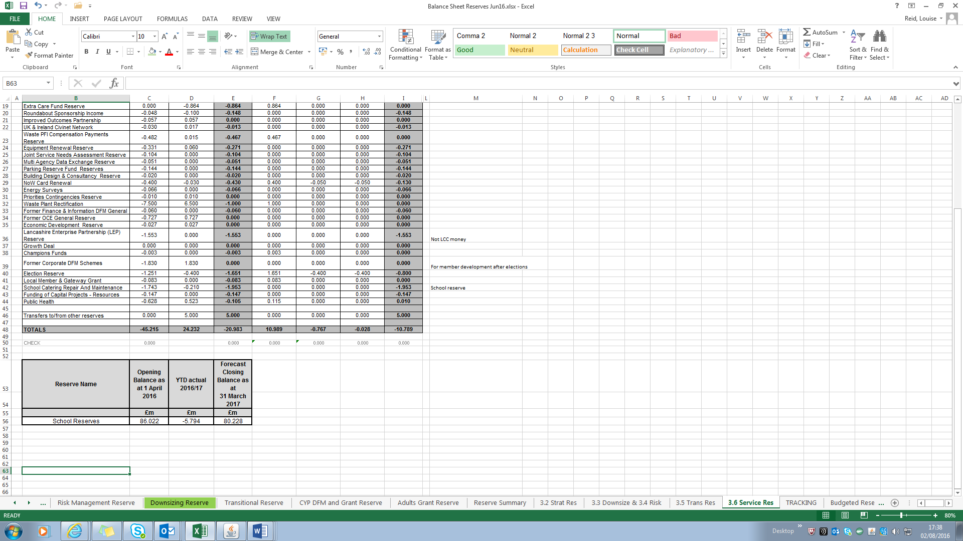

**4. Impact of 2016/17 Outturn Forecast**

The current monitoring report is showing an underspend of £13.271m. Any underspend at the year-end can be transferred to the Transitional Reserve.

**5. Transfers between Reserves**

In the previous report to Cabinet in September the transfers below were included between reserves:



A further review of reserves held has identified areas where there are no commitments or reasons that a reserve can be released, therefore the following additional transfers between reserves that have been included in this report are:



**Annex A – Strategic Investment Reserve**

|  |  |  |  |  |  |  |  |  |
| --- | --- | --- | --- | --- | --- | --- | --- | --- |
| **STRATEGIC INVESTMENT RESERVE** | **Opening Balance as at 1 April 2016** | **2016-17 Forecast Spend** | **2016-17 Transfers to / from other reserves** | **2016-17 Forecast Closing Balance** | **2017-18 Forecast Spend** | **2018-19 Forecast Spend** | **2019-20 Forecast Spend** | **Total as at 31 March 2020** |
|  | **£m** | **£m** | **£m** | **£m** | **£m** | **£m** | **£m** | **£m** |
| Promoting Sustainable Employment for Young People | -0.304 | 0.304 | 0.000 | **0.000** | 0.000 | 0.000 | 0.000 | **0.000** |
| Young Person's Travel | -0.194 | 0.000 | 0.194 | **0.000** | 0.000 | 0.000 | 0.000 | **0.000** |
| Economic Development - GAMMA | -0.017 | 0.017 | 0.000 | **0.000** | 0.000 | 0.000 | 0.000 | **0.000** |
| Economic Enterprise Zone Strategic Development | -0.500 | 0.500 | 0.000 | **0.000** | 0.000 | 0.000 | 0.000 | **0.000** |
| Economic Development - Exertis | -0.500 | 0.500 | 0.000 | **0.000** | 0.000 | 0.000 | 0.000 | **0.000** |
| Economic Development - Boost Continuation | -1.929 | 0.643 | 0.000 | **-1.286** | 0.643 | 0.643 | 0.000 | **0.000** |
| Armed Forces Apprentice Costs | -1.770 | 0.287 | 0.000 | **-1.483** | 0.243 | 0.240 | 0.060 | **-0.940** |
| Early Action /Early Response | -0.100 | 0.100 | 0.000 | **0.000** | 0.000 | 0.000 | 0.000 | **0.000** |
| Green Energy Fund | -5.000 | 0.000 | 5.000 | **0.000** | 0.000 | 0.000 | 0.000 | **0.000** |
| Core Systems Transformation | -0.657 | 0.000 | 0.000 | **-0.657** | 0.657 | 0.000 | 0.000 | **0.000** |
| **Total on Strategic Investment Reserve** | **-10.971** | **2.351** | **5.194** | **-3.426** | **1.543** | **0.883** | **0.060** | **-0.940** |

**Annex B – Downsizing and Risk Management Reserves**

|  |  |  |  |  |  |  |  |  |
| --- | --- | --- | --- | --- | --- | --- | --- | --- |
| **DOWNSIZING & RISK MANAGEMENT RESERVES** | **Opening Balance as at 1 April 2016** | **2016-17 Forecast Spend** | **2016-17 Transfers to / from other reserves** | **2016-17 Forecast Closing Balance** | **2017-18 Forecast Spend** | **2018-19 Forecast Spend** | **2019-20 Forecast Spend** | **Total as at 31 March 2020** |
| **Downsizing Reserve** | **£m** | **£m** | **£m** | **£m** | **£m** | **£m** | **£m** | **£m** |
| Redundancy provision | -50.849 | 8.210 | 21.470 | **-21.169** | 12.109 | 9.060 | 0.000 | **0.000** |
| Transitional costs associated with Transformation Programme | -2.328 | 0.000 | 2.328 | **0.000** | 0.000 | 0.000 | 0.000 | **0.000** |
| Review for Adult Social Care (Newtons) | -7.000 | 5.961 | 0.000 | **-1.039** | 1.039 | 0.000 | 0.000 | **0.000** |
| Unallocated surplus | -4.664 | 0.000 | 4.664 | **0.000** | 0.000 | 0.000 | 0.000 | **0.000** |
| **Total on Downsizing Reserve** | **-64.841** | **14.171** | **28.462** | **-22.208** | **13.148** | **9.060** | **0.000** | **0.000** |
|  |  |  |  |  |  |  |  |  |
| **Risk Management Reserve** | **£m** | **£m** | **£m** | **£m** | **£m** | **£m** | **£m** | **£m** |
| Occupational Health | 0.003 | 0.000 | -0.003 | **0.000** | 0.000 | 0.000 | 0.000 | **0.000** |
| Adults LD Remodelling Reserve | -0.784 | 0.784 | 0.000 | **0.000** | 0.000 | 0.000 | 0.000 | **0.000** |
| Provision to mitigate against risk DoLS- Deprivation of Liberty Safeguards | -2.900 | 0.424 | 0.000 | **-2.476** | 2.476 | 0.000 | 0.000 | **0.000** |
| Impact of Fairness Commission Report Council Welfare Provision and the Care and Urgent Needs | -3.000 | 0.000 | 0.000 | **-3.000** | 3.000 | 0.000 | 0.000 | **0.000** |
| School Crossing Patrols | -1.500 | 0.000 | 1.500 | **0.000** | 0.000 | 0.000 | 0.000 | **0.000** |
| Social Work Dedicated Review Team | -2.653 | 1.156 | 0.000 | **-1.497** | 1.497 | 0.000 | 0.000 | **0.000** |
| Liquid Logic - Children's Services | -0.400 | 0.275 | 0.125 | **0.000** | 0.000 | 0.000 | 0.000 | **0.000** |
| Liquid Logic - Adult Social Care | -0.250 | 0.000 | 0.250 | **0.000** | 0.000 | 0.000 | 0.000 | **0.000** |
| Payment of additional allowances when staff are on leave | -1.300 | 1.300 | 0.000 | **0.000** | 0.000 | 0.000 | 0.000 | **0.000** |
| Transfer to Transitional Reserve for Wellbeing | -3.000 | 0.000 | 3.000 | **0.000** | 0.000 | 0.000 | 0.000 | **0.000** |
| **Total on Risk Management Reserve** | **-15.784** | **3.939** | **4.872** | **-6.973** | **6.973** | **0.000** | **0.000** | **0.000** |

**Annex C – Transitional Reserve & Transition of Services Reserve**



**Annex D – Service Reserves**



*Note: included in the LCC Waste Plant Rectification reserve at 31st March 2017 is a forecast £0.491m held for Blackpool Borough Council.*